**Linux Practice**

1)Create three subdirectories: Music, Pictures, and Videos with the parent directory demo using single command.

2. Create sets of empty practice files to use during this session.

a. Create six files with names of the form songX.mp3.

b. Create six files with names of the form snapX.jpg.

c. Create six files with names of the form filmX.avi.

In each set, replace X with the numbers 1 through 6

3. Move the song files to the Music subdirectory, the snapshot files to the Pictures subdirectory, and the movie files to the Videos subdirectory.

4. Create three subdirectories for organizing your files into projects. Name the subdirectories friends, family, and work. Use a single command to create all three subdirectories at the same time.

5. Copy a selection of new files to the project directories family and friends. Use as many commands as needed. You do not have to use only one command as in the example. For each project, first change to the project directory, then copy the source files to this directory. Keep in mind that you are making copies, therefore the original files will remain in their original locations after the files are copied to the project directories.

a. Copy files (all types) containing the numbers 1 and 2 in to the friends subdirectory.

b. Copy files (all types) containing the numbers 3 and 4 in to the family subdirectory.

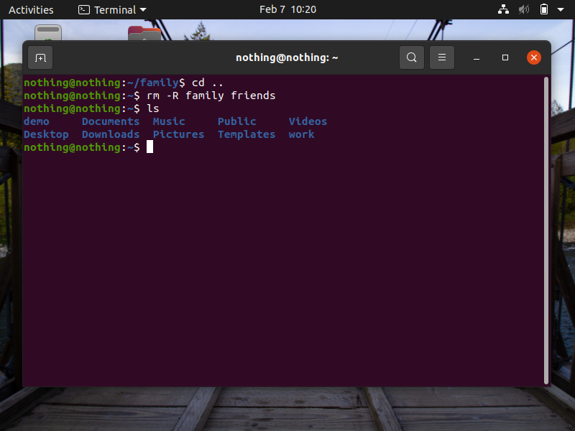6. Recursively delete both the family and friends subdirectories and their contents.

7. Delete all the files in the work project, but do not delete the work directory.

Nothing to perform.

8. Delete the empty work directory.

